Chris Prestwich

CS456

Twitter Clone with Firebase

Things I did:

Basic Functionality: 85pts

Read phone location and add Latitude and Longitude to the message: 5pts

Change the name of the sender at will: 3pts

Add a timestamp to the message: 2pts

Total: 95pts (unless you thing the sender and timestamp are worth more)

Basic Functionality:

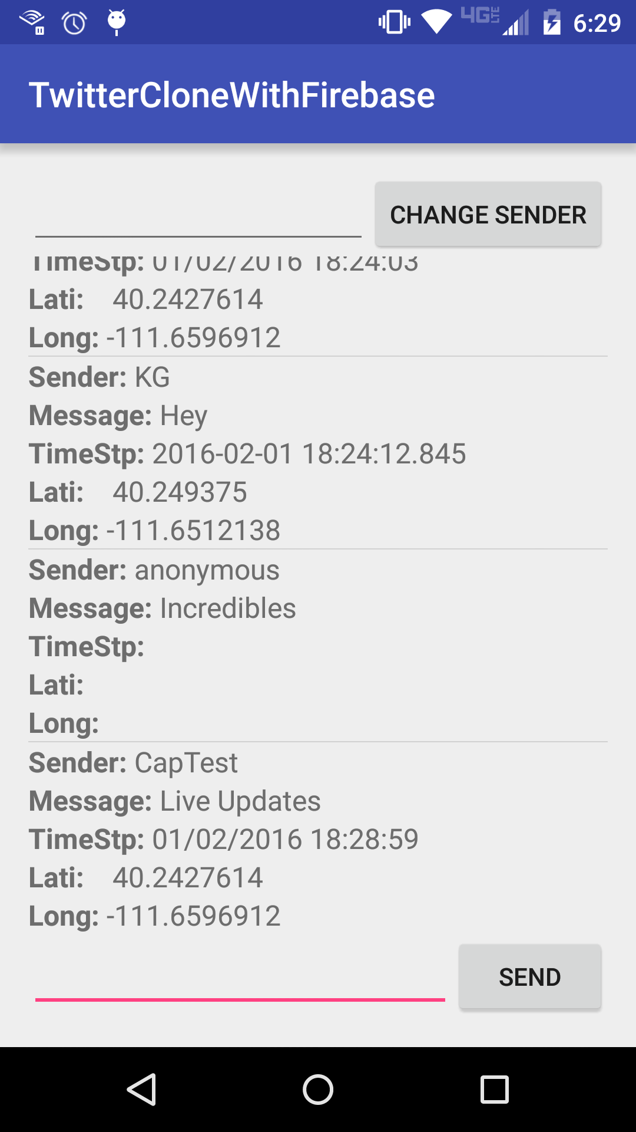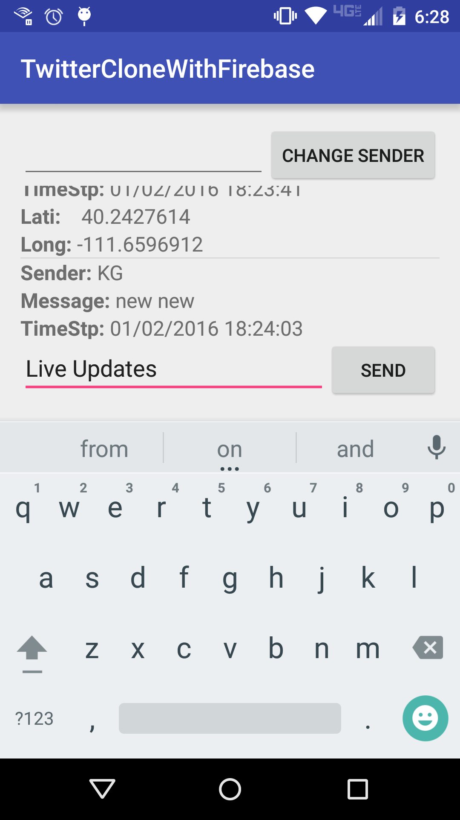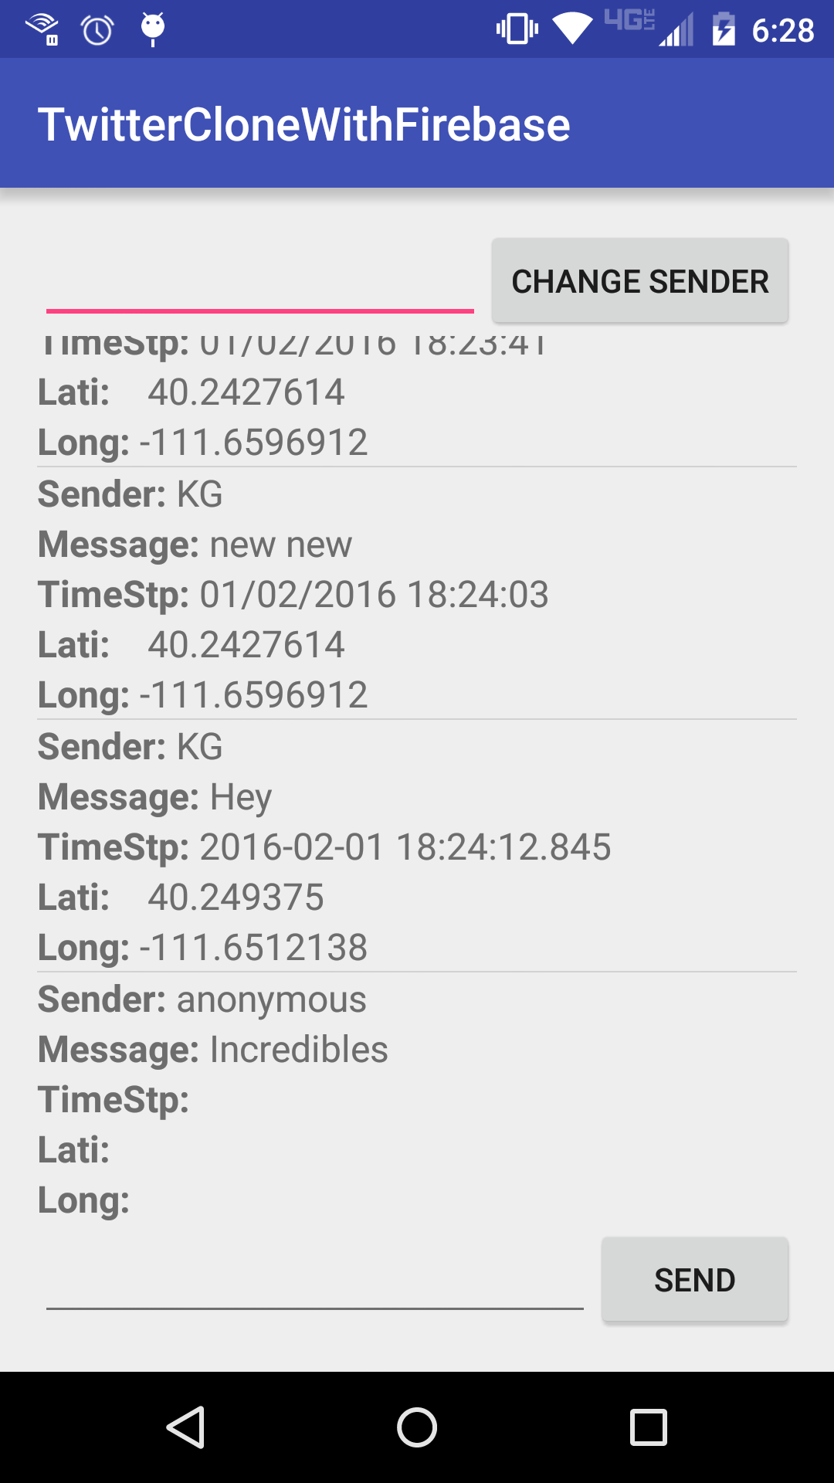

Here we see reading and displaying all messages on startup and the sending of a post with a live update to our message list.

Extras:

Timestamp, Longitude and Latitude:

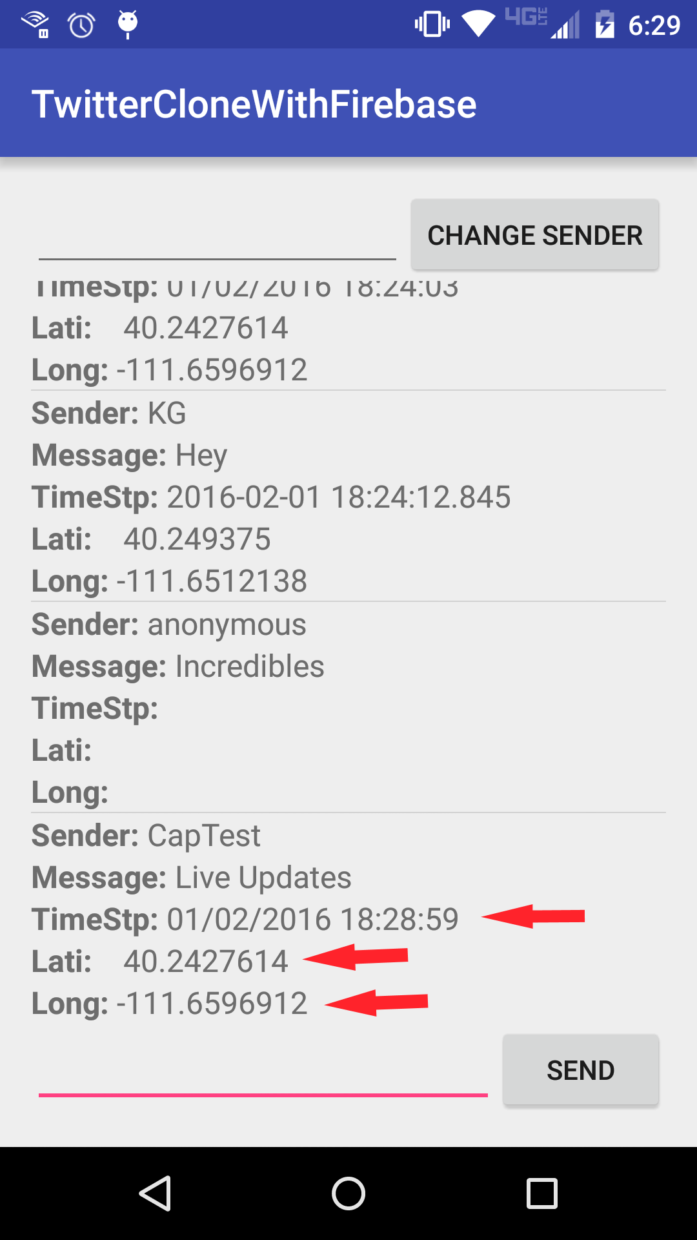

Change Sender at Will:

